Prototype WebRTC detection

Introduction
For my Sprint 2 user story, I tasked myself with building a prototype for an application that detects the users WebRTC stun candidates. I decided the best method to do this was through a web application, so I coded and deployed one using html and javascript. This document will explain how the program works, what STUN candidates are, and how the results compare with a VPN turned on and off. I’ll also include a github link to the code.

What the program does
At its core level, the program fetches a normal network request for the user's public IP address by connecting to an API, and compares it against the addresses that are detected from WebRTC STUN candidates. It gathers these STUN candidates from ICE (Interactive Connectivity Establishment) servers, which are then displayed on screen for the user to examine. Once the normal network request and STUN candidates have been completed, the program determines if the users public or local IP have been exposed. It does this by checking the availability of a host IP or SRFLX (server reflexive candidate), both of which allow a device to communicate over the internet using its public IP.

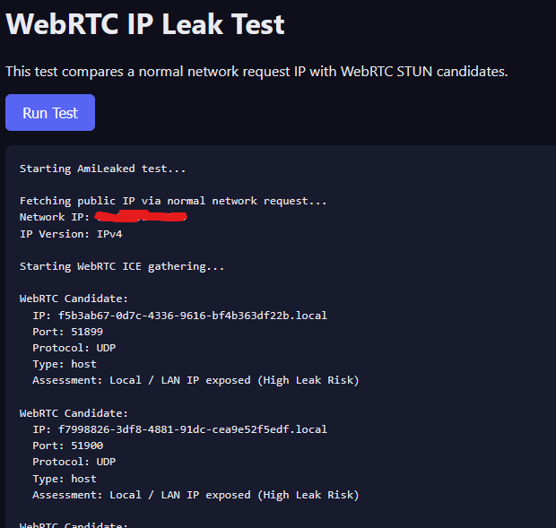

What are STUN candidates?
STUN candidates are networking vectors that are derived from ICE (Interactive Connectivity Establishment) servers whenever a client makes a peer connection from a WebRTC request. They represent the public facing port and IP that the source device seems to have when seen by those ICE servers. These candidates often reveal your real public IPv4 and IPv6 address, bypassing typical VPNs and proxies.

VPN on vs off behavior
When my VPN is turned off, the program prioritizes an IPv6 connection when initiating the normal network request, which returns with my real public IP. It then collects a total of 7 STUN candidates, five of which use ports 58174 and 58175. They all show IPv6 public IPs, with only the last STUN candidate showing my real IPv4 public IP.

When my VPN is turned on, the initial normal network request comes back with my VPNs IPv4 public IP instead of my real one. It collected 5 STUN candidates, 4 of which showed the IPs of my VPN. The last STUN candidate still shows my real IPv4 public IP however, as did it when I had the VPN off.

The VPN seems to have concealed all of my public IPs revealed by the STUN candidates, except for the last one. This candidate was srflx with the UDP protocol.

Github link to program
https://github.com/SwellEquation/WebRTC-STUN-Candidate-Detection

